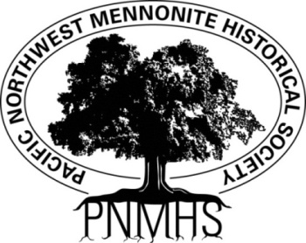**Pacific Northwest Mennonite Historical Society**

**6030 South Whiskey Hill Road Hubbard OR 97032-9406**

**Ph: (503) 266-6447**

***Email:******pnmhs.volunteer@gmail.com Web:*** [***pnmhs.org***](http://www.pnmhs.org/)

*Preserving the past to illuminate the future*

**Church Records Wanted for the Historical Library & Archives**

The following congregational records are wanted on an ongoing basis from Anabaptist connected congregations in the Pacific Northwest. Please share this list with your church office manager or church historian.

**Primary Items**

1. Weekly Bulletins
2. Annual Reports Including Annual Financial Summaries
3. Pictorial Directories
4. Baptismal Records
5. Congregational Newsletters
6. Church Constitutions and By-Laws
7. Church leadership Meeting Minutes (in chronological order)
8. Congregational Meeting Minutes
9. Digital Recordings and/or Sermon Notes of Special Services such as Ordinations, Baptisms, Funerals & Memorial Services, Church Anniversaries

**Secondary Items**

1. Minutes of Meetings Related to Church Polity Discussions
2. Sermons and Presentations Focused on Theological Issues or Topics
3. Photographs related to the Congregation (Buildings, People, Events with identifying information)
4. Sunday School Curriculum, Christmas Programs, Musical Performances, Etc.
5. Architectural Records, Building Plans
6. Publicity about the congregation in local media

We would like to receive these items on an annual basis. However if you have a backlog from years past, we would welcome them as well. The various types of records listed above should not be intermixed, but filed separately and in chronological order, oldest to newest. While paper copies are still preferred, digital copies on thumb drives will also be accepted. Materials should be delivered to:

**Pacific NW Mennonite Heritage Society, 6030 Whiskey Hill Rd., Hubbard, OR 97032**

**Hours open: Wednesdays 9:00 a.m. – 3:00 p.m.**

Thank You. If you have questions call 503-266-6447 or email pnmhs.volunteer@gmail.com